
Lab Report
Department: Department of Computer Science and Engineering
Course Title: Computer Networks Lab
Course Code: CSE0612314
Experiment No.: 05
Experiment Title: VLAN Configuration using Switch.

Submitted to:
Teacher’s name: Trisha Sarkar
Designation: Lecturer
Department of CSE
UITS

Submitted by:
Student name: Badhon Kumar Roy
Student Id: 04324205101042
Section: 5A2
Semester: Autumn 2026
Batch: 56th
Date of Submission: 17 October, 2026
Laboratory Report
1. Experiment Number: 05
2. Experiment Title: VLAN Configuration using Switch.

3. Objectives:
- To understand the concept and purpose of Virtual Local Area Networks (VLANs).
- To create and configure three separate VLANs on a Cisco switch.
- To assign switch ports to their respective VLANs and connect PCs to those ports.
- To test connectivity between PCs in different VLANs using the ping command.
- To observe packet movement and communication behavior using Simulation Mode in Cisco Packet Tracer.
4. Theoretical Background:
A Virtual Local Area Network (VLAN) is a logical division of a physical network into separate broadcast domains. It allows a network administrator to group devices into different networks even when they are connected to the same physical switch. In this experiment, three VLANs named VLAN 10, VLAN 20, and VLAN 30 were configured on a Cisco 2960 switch using Cisco Packet Tracer. Each VLAN was assigned a separate group of switch ports, and two PCs were connected to each VLAN. IP addresses were assigned to the PCs so that connectivity could be tested using the ping command. The experiment also used Simulation Mode to observe how packets moved through the network. Since the PCs belonged to different VLANs, communication between them was not possible through the Layer 2 switch alone. This experiment helped demonstrate how VLANs separate network traffic and why inter-VLAN routing is needed for communication between different VLANs.
5. Tools and Software used:
- Cisco Packet Tracer
- PC-PT
- 2960-24TT Switch
- Wires

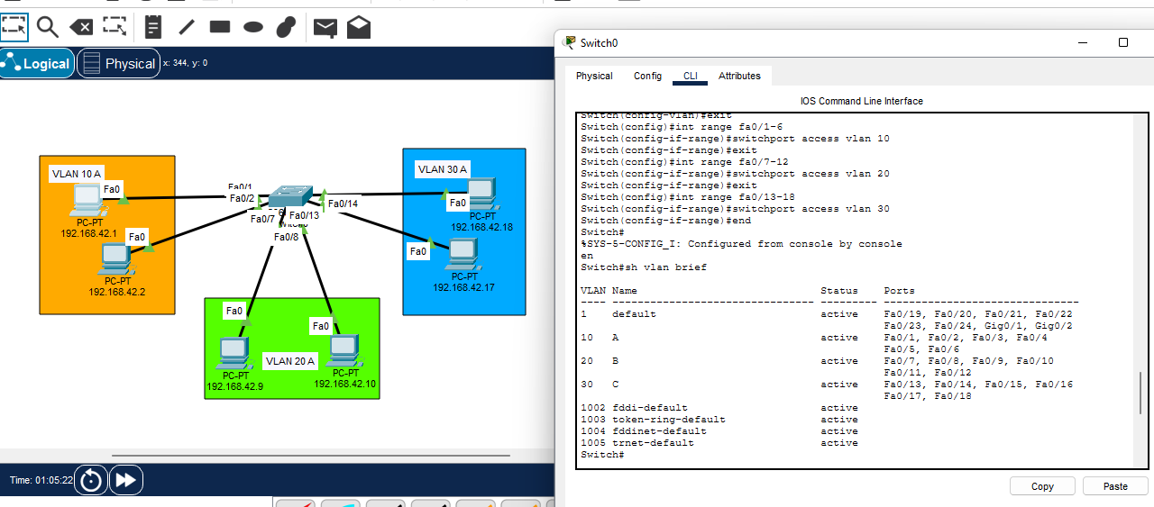
6. Network Topology:

Figure 5.1: Network topology showing three VLANs configured.

7. Methodology:
- First, Cisco Packet Tracer was opened, and one 2960-24TT switch and six PC-PT devices were placed in the workspace.
- The six PCs were arranged into three groups, with two PCs in each group to represent the three VLANs.
- All PCs were connected to the switch using copper straight-through cables.
- The switch CLI was opened, and configuration mode was entered to create the required VLANs.
- Three VLANs were configured on the switch: VLAN 10 named A, VLAN 20 named B, and VLAN 30 named C.
- The switch ports from Fa0/1 to Fa0/6 were assigned to VLAN 10, ports Fa0/7 to Fa0/12 were assigned to VLAN 20, and ports Fa0/13 to Fa0/18 were assigned to VLAN 30.
- IP addresses were assigned to the PCs. The addresses shown in the topology included 192.168.42.1, 192.168.42.2, 192.168.42.9, 192.168.42.10, 192.168.42.17, and 192.168.42.18.
- The show vlan brief command was executed on the switch to verify that the VLANs were active and the correct ports were assigned to them.
- The Command Prompt on a PC was opened, and the ping command was used to test communication with another PC in a different VLAN.
- A ping test was performed from the PC with IP address 192.168.42.1 to the PC with IP address 192.168.42.9. The request timed out, showing that the two PCs could not communicate successfully in the current configuration.
- Finally, Simulation Mode was used to observe packet movement and understand how VLAN separation affects communication between PCs connected to the same switch.
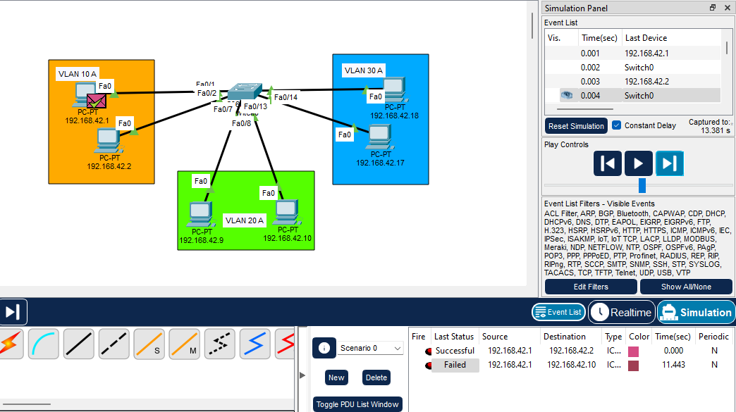
8. Output:
Figure 5.2: Packet movement observed in Simulation Mode
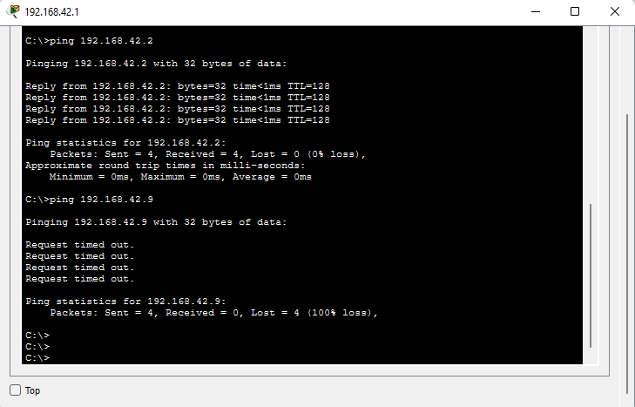
Figure 4.5: CMD Ping Results
9. Conclusion:
In this experiment, three VLANs were configured on a Cisco 2960 switch using Cisco Packet Tracer. The switch ports were assigned to VLAN 10, VLAN 20, and VLAN 30, and six PCs were connected to the switch. The show vlan brief command was used to verify the VLAN configuration, while the ping command was used to test communication between PCs in different VLANs. The ping test timed out because inter-VLAN routing was not configured in the current setup. Overall, the experiment helped develop a better understanding of VLAN configuration, network separation, and the need for routing to enable communication between different VLANs.

